SQL BASIC

After where:

1. Table id binding id = id
2. When with some conditions in other tables, it is and and and….

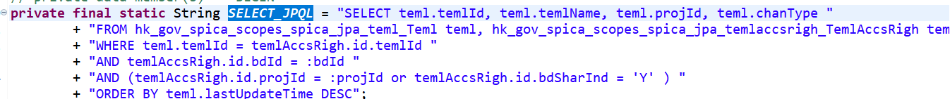

HSQL (Hibernate SQL):

Cannot select \* from table limit 1000;

it must use a built in function

setMaxResults()

